# [Chris Meloni says he and Mariska Hargitay are 'inextricably linked' by 'SVU' characters](https://www.today.com/today/amp/tdna187710?__twitter_impression=true&s=09)

"We don’t have this relationship with anyone else."

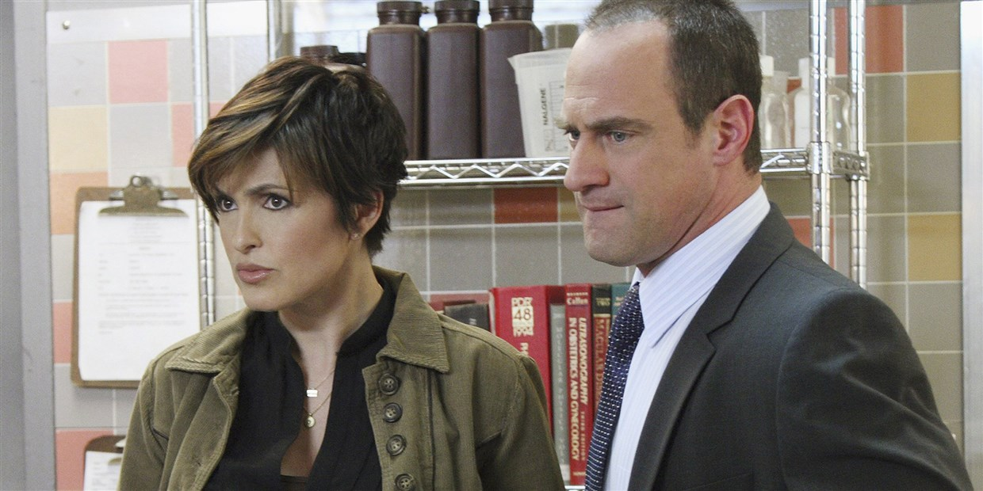

Christopher Meloni played Elliot Stabler on "Law & Order: SVU" for 12 seasons. He'll reprise his role on "SVU" spinoff "Organized Crime."NBC

* SHARE THIS -

July 24, 2020, 9:45 AM EDT / Source: TODAY

By Lindsay Lowe

[Benson and Stabler](https://www.today.com/popculture/mariska-hargitay-chris-meloni-have-sweetest-law-order-svu-memories-t171075), together again!

“Law & Order: SVU” fans were ecstatic when [Chris Meloni announced](https://www.today.com/popculture/christopher-meloni-bringing-back-svu-character-new-series-t177221) he would be reprising his role as Elliot Stabler in a new [“SVU” spinoff series this fall](https://www.today.com/popculture/mariska-hargitay-christopher-meloni-reunite-svu-spinoff-t187275), as well as making at least one guest appearance on “SVU” nearly a decade after leaving the show.

*Watch* [*TODAY All Day*](https://www.today.com/allday?icid=ed_npd_td_to_tad_200717)*! Get the best news, information and inspiration from TODAY, all day long.*

As the return of Elliot Stabler draws closer — [Meloni said filming is supposed to begin in September](https://www.etonline.com/chris-meloni-on-his-law-order-return-maxxx-and-love-for-eccentric-characters-exclusive-150161) — the actor opened up about his lasting bond with “SVU” co-star Mariska Hargitay.

“(‘SVU’) gave birth to Mariska and Meloni and Benson and Stabler. So we’re kind of inextricably linked and connected in that way,” Meloni said in an interview this week with [Entertainment Tonight](https://www.etonline.com/chris-meloni-on-his-law-order-return-maxxx-and-love-for-eccentric-characters-exclusive-150161). “Beyond that, we’re very good friends. I think we value each other.”

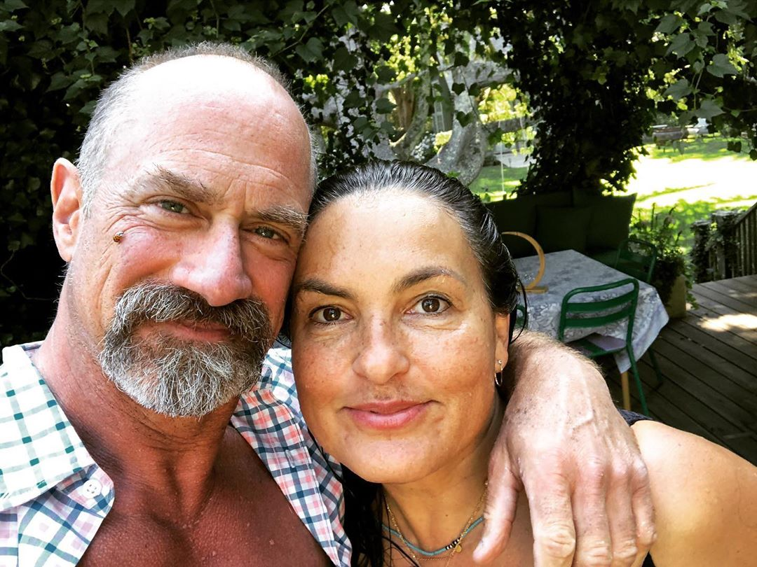

[He and Hargitay recently reunited](https://www.today.com/popculture/mariska-hargitay-christopher-meloni-reunite-svu-spinoff-t187275) ahead of the [upcoming season of "SVU,"](https://www.today.com/popculture/elliot-stabler-returning-law-order-svu-22nd-season-premiere-t180582) with both [sharing photos](https://www.instagram.com/p/CC2UcUdgAgI) of themselves hanging out outside.

Meloni told ET it's easy for them to pick up right where they left off.

“We’ve said it’s like we don’t have this relationship with anyone else,” he said. “It’s unique, it’s full of laughter, she’s full of love. We just kind of fall seamlessly into that place every time we see each other.”

Meloni [has also previously hinted](https://www.today.com/popculture/christopher-meloni-predicts-benson-stabler-crossover-svu-spinoff-t186095) that there may be some “SVU” crossover episodes with his new spinoff series, “Law & Order: Organized Crime,” which will follow Stabler as he leads an NYPD organized crime unit while coming to terms with a “devastating personal loss.”

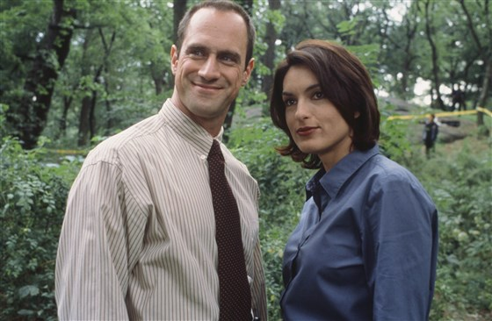Benson and Stabler began fighting crime together in 1999.Jessica Burstein / NBC

Meloni left “Law & Order: SVU” in 2011, and his rather sudden exit left some fans unsatisfied and missing the on-screen chemistry between him and Hargitay, who had starred together on the show since it began in 1999.

As he prepares to return to the “SVU”-niverse and reprise his role as Stabler on “Organized Crime,” Meloni said he hopes to explore some of the unresolved issues between his character and Olivia Benson.

“It just has to be,” [he told the New York Post](https://www.today.com/popculture/christopher-meloni-predicts-benson-stabler-crossover-svu-spinoff-t186095) earlier this month. “Benson and Stabler are inextricably linked, locked and connected. I think there is truly and deeply a worthwhile, inherent drama in exploring that relationship and the complexity of how Stabler left — the unresolved emotions both characters feel and how the fans feel.”

He also said that now just feels like the right time to reprise his role as Stabler.

“A certain piece just fell into place,” Meloni told ET. “For me, there were just personal things that I was like, ‘You know, now is a good time.’ That was it. There was nothing secret. It just was effortlessly correct.”